**Project Title: SMART SOLUTION FOR RAILWAYS Project Design Phase-I** - **Solution Fit Template Team id:PNT2022TMID20139**

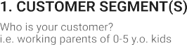

**PASSENGER**

**RAILWAY**

**MANAGEMENT**

**TTR**

TOURISTSTS

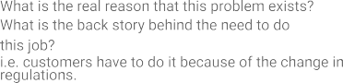

**Challenges of traditional railways**

**Challenges of traditional railways**

# 3. TRIGGERS TR

What triggers customers to act?

# 10. YOUR SOLUTION SL

If you are working on an existing business, write down your current solution first, fill in the canvas, and check how much it fits reality.

If you are working on a new business proposition, then keep it blank until you fill in the canvas and come up with a solution that fits within customer limitations, 8.**CHANNELS OF BEHAVIOUR** CH

# 4. EMOTIONS: BEFORE / AFTER EM

